Understanding anxiety
- Most of the time, when life is ‘normal’, we are operating in ‘competency mode.’
- Competency mode requires access to the prefrontal cortex, which allows for reflection, planning, introspection, imagination, a sense of morality, etc.
- Anxiety is basically all about fear – underlying fear, in your face fear, known and unknown fear. A quite ancient part of our brain, the amygdala, registers this fear and triggers a complex set of responses to ensure we survive in threatening situations.
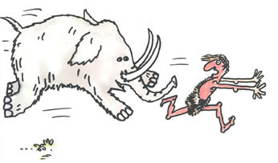
- Decision as to whether to go into survival or competency mode is made by the amygdala – based on an appraisal of threat. It gives us three choices – fight, flight or freeze.
- In survival mode, strong emotions hi-jack the prefrontal cortex so you can’t access your competency mode – it is still there, just temporarily unavailable. The primitive reptilian brain takes over, and with some dramatic effects, but only till the hormones run out.

